
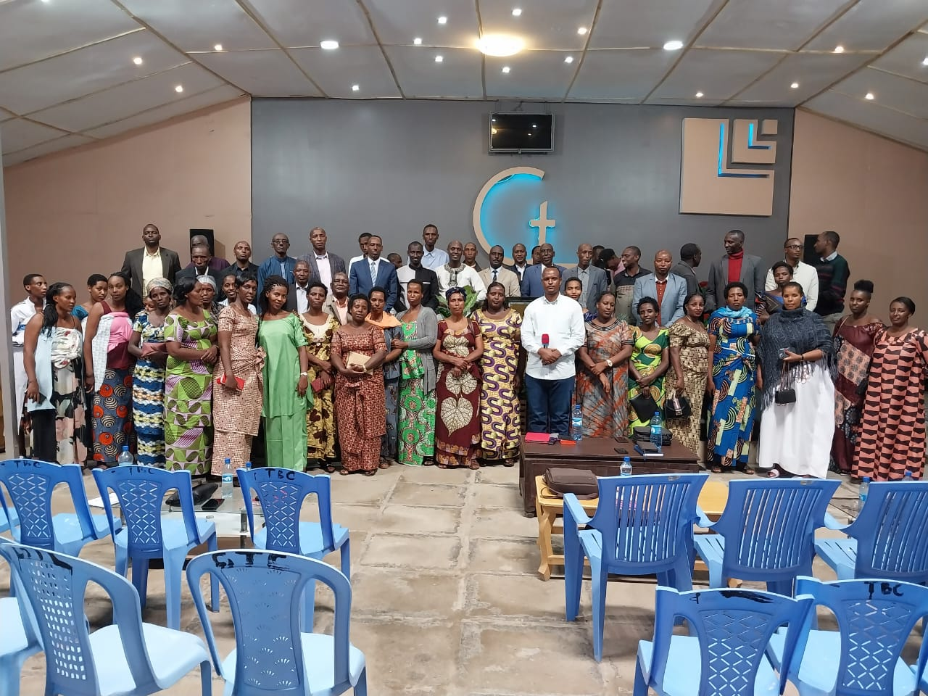

ANNUAL REPORT FOR THE YEAR FROM JANUARY TO DECEMBER 2023

- Introduction
Shechem Global Ministries is a Ministry committed and dedicated to serve God, changing lives, declare peace, build the spirit of hope in many persons’ minds, transforming our community and deepening our relationship with Jesus Christ meeting the needs of you and your loved ones using sound Biblical principles of spirituality. The Ministry was founded in 2000 by Ruhorimbere Denis and Nyiramanyana Esther, founder and co-founder respectively.
This ministry was a fruit of prayers since many years ago from the time that God put in founders’ Hearts the Calling of serving him. The Ministry aspires to strengthen each person’s confidence and hope in Jesus Christ our savior at every side in their lives, hearten personal and spiritual growth through prayer, Bible study, conferences, seminars, Crusades and participation in activities of the Ministry and the Community.
The Ministry has been planted and operates in Uganda, Rwanda, Burundi, Tanzania, DRC, South Sudan and Kenya.
- Summary of activities implemented by cost category
The activities implemented by the Ministry in 2023 focused on four main pillars:
- Equip and Empower Church Leaders and Planters
- Equip Youth (Small Businesses)
- Equip Women (Capacity Building and Small Businesses)
- Help Orphans in Education and Health.
  - Equip and Empower Church Leaders and Planters
The main activities under this pillar included:
- Trainings, workshops and seminars
- Distribution of training materials
- Support for Church planting initiatives

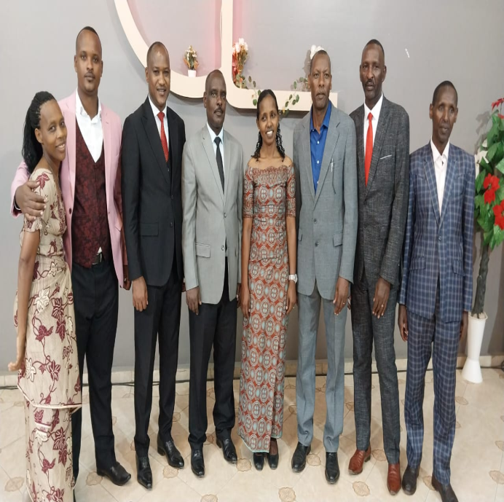

The costs of activities under pillar are broken down in the table below:

Activity | Sub activity | Unit cost in $ | Unit of measure | Total cost
Training Workshops and Seminars (conducted 4 major workshops, i.e. one each quarter) to enhance leadership and church planting skills | Trainer fees | $1,000 | 5 trainers | $5,000
 | Venue rental | $375 | Per workshop (4 workshops) | $1,500
 | Travel and Accommodation | $625 | Per workshop (4 workshops) for trainers and participants | $2,500
Distribution of Training Materials | Provided books, manuals, and digital resources to 50 participants | $40 | 50 participants | $2,000
Support for Church Planting Initiatives | Provided financial grants to 8 new church projects | $500 | 8 churches planted | $4,000
Total |  |  |  | $15,000

  - Equip Youth (Small businesses)
The main activities under this pillar included:
- Business training workshops
- Small business grants or loans
- Coaching and mentorship programs
- Distribution of training materials.

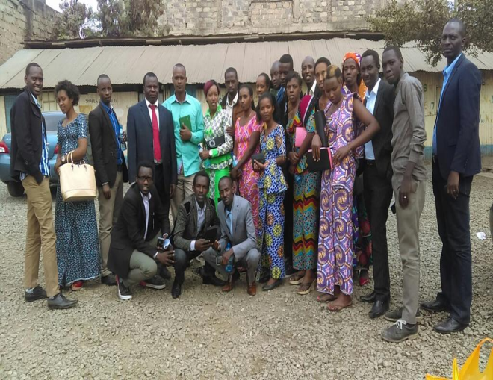
The costs of activities under pillar are broken down in the table below:

Activity | Sub activity | Unit cost in $ | Unit of measure | Total cost
Business Training Workshops (conducted 4 business training workshops, one per quarter) | Trainer fees | $500 | 5 trainers | $2,500
 | Venue Rental | $250 | Per workshop (4 workshops) | $1,000
Small Business Grants or Loans | Provided financial assistance to 10 youth entrepreneurs | $500 | Per entrepreneur (10 entrepreneurs) | $5,000
Mentorship Programs | Organized mentorship programs with 10 mentors | $100 | 10 mentors | $1,000
Training Materials | Distributed training materials to 50 participants | $20 | 50 Participants | $1,000
 |  |  |  | $10,500

  - Equip Women (Capacity Building and Small Businesses)

The main activities under this pillar included:
- Skills development workshop
- Small business grants or loans
- Networking events
- Distribution of training materials
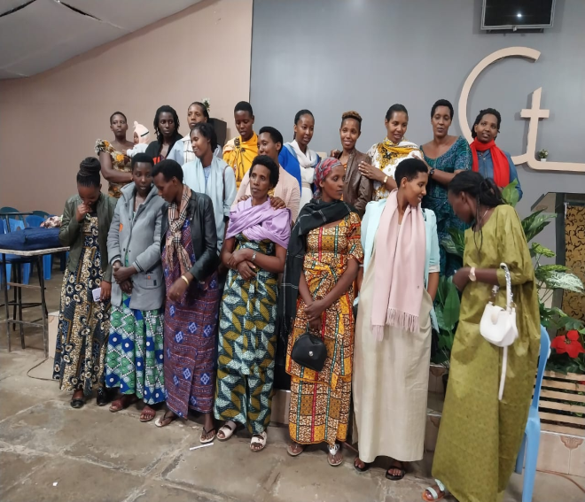

The costs of activities under pillar are broken down in the table below:

Activity | Sub activity | Unit cost in $ | Unit of measure | Total cost
Skills Development Workshops (conducted 4 skill development workshops, one per quarter) | Trainer fees | $400 | 5 trainers | $2,000
 | Venue rental | $250 | Per workshop (4 workshops) | $1,000
Small Business Grants or Loans | Provided financial assistance to 8 women entrepreneurs | $500 | 8 Women entrepreneurs | $4,000
Networking Events | Organized 4 networking events | $250 | 4 events | $1,000
Training Materials | Provided materials to 40 participants | $25 | 40 Participants | 1,000
Total |  |  |  | $9,000
  - Help Orphans in Education and Health
The main activities under this pillar included:
- Proving meals and drinks
- Educational support
- Health care support.

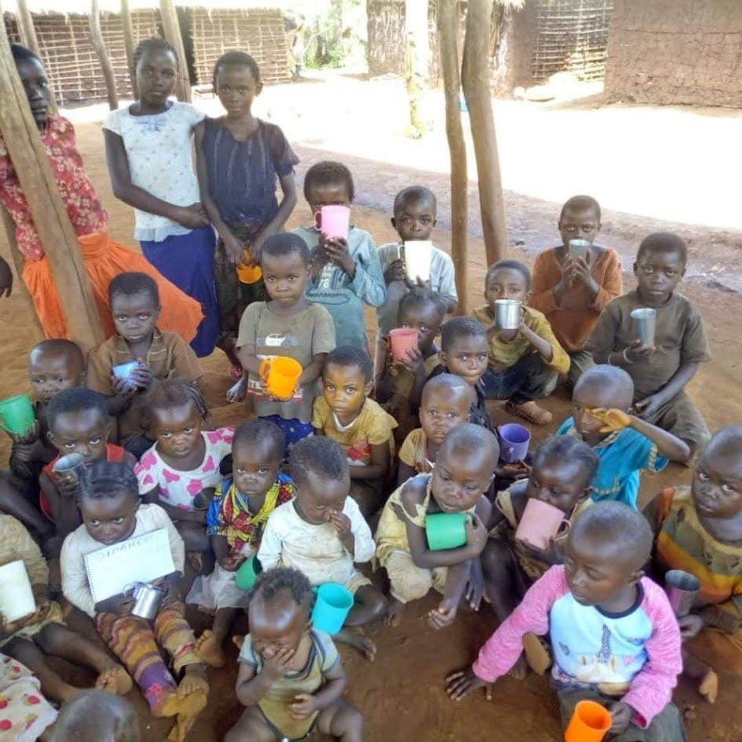

The costs of activities under pillar are broken down in the table below:

Activity | Sub activity | Unit cost in $ | Unit of measure | Total cost
Providing Meals and Drinks | Provided daily meals and drinks to 80 children for the entire year | $0.34 | 80 children for 365 days | $10,000
Educational Support | Supported 20 children with tuition, books, and supplies | $300 | 80 children | $6,000
Health care support | Provided medical check-ups and treatments for 30 children | $133 | 30 children | $4,000
 |  |  |  | $20,000

  - Operational costs

The Ministry incurred other operational costs including:
- Payment of staff salaries
- Office supplies and equipment
- Communication costs
- Transportation costs
- Miscellaneous costs.

The costs of operational costs are broken down in the table below:

Activity | Sub activity | Unit cost in $ | Unit of measure | Total cost
Staff salaries | Coordinator | $6,000 | Annually | $6,000
 | 2 Assistants | $3,000 | 2 Assistants, Annually | $6,000
Office Supplies and Equipment | Costs for necessary office supplies and equipment (includes stationery, computers, and other office necessities) | $3,000 | Annually | $3,000
Communication | Communication | $125 | Per month | $1,500
Transportation | Costs for vehicle maintenance and fuel | $250 | Per month | $3,000
Miscellaneous Costs | Other miscellaneous costs | $1,000 | Annually | $1,000
Total |  |  |  | 20,500

- Breakdown of costs by quarter

The breakdown of costs incurred by quarter is summarized in the table below:

Activity | Sub activity | January-March in $ | April-June in $ | July-September in $ | October-December in $ | Total in $
Church Leaders Training | Conducted first workshop | 3,500 | 3,500 | 1,875 | 1,875 | 10,750
 | Distributed materials | 500 | 500 | 625 | 625 | 2,250
 | Provided grants to 2 church planters | 1,000 | 1,000 | - | - | 2,000
Sub total |  | 5,000 | 5,000 | 2,500 | 2,500 | 15,000
Youth Business Training | Workshops | 1,000 | 1,000 | 1,000 | 1,000 | 4,000
 | Distributed materials | 250 | 250 | 250 | 250 | 1,000
 | Provided grants to 3 youth entrepreneurs | 1,500 | 1,500 | 500 | 500 | 4,000
 | Mentorship stipends | 750 | 750 | - | - | 1,500
Subtotal |  | 3,500 | 3,500 | 1,750 | 1,750 | 10,500
Women Capacity Building | Workshops | 1,500 | 1,500 | 1,000 | 1,000 | 5,000
 | Distributed materials | 250 | 250 | 250 | 250 | 1,000
 | Provided grants to 2 women entrepreneurs | 1,000 | 1,000 | - | - | 2,000
 | Networking events | 250 | 250 | 250 | 250 | 1,000
Sub total |  | 3,000 | 3,000 | 1,500 | 1,500 | 9,000
Orphan Support (Meals, Education) | Meals and drinks | 2,500 | 2,500 | 2,500 | 2,500 | 10,000
 | Educational support | 1,500 | 1,500 | 1,500 | 1,500 | 6,000
 | Health care support | 1,000 | 1,000 | 1,000 | 1,000 | 4,000
Subtotal |  | 5,000 | 5,000 | 5,000 | 5,000 | 20,000
Operational costs | Staff salaries | 3,000 | 3,000 | 3,000 | 3,000 | 12,000
 | Office supplies and equipment | 750 | 750 | 750 | 750 | 3,000
 | Communication | 375 | 375 | 375 | 375 | 1,500
 | Transportation | 750 | 750 | 750 | 750 | 3,000
 | Miscellaneous | 250 | 250 | 250 | 250 | 1,000
Subtotal |  | 5,125 | 5,125 | 5,125 | 5,125 | 20,500
Grand total |  | 21,625 | 21,625 | 15,875 | 15,875 | 75,000

- CONCLUSION

In 2023, our Ministry focused on empowering church leaders, youth, and women, and supporting orphans in their education and health. The total cost for these activities, including operational expenses, amounted to $75,000. This budget was allocated across the year, ensuring consistent support and impactful programs every quarter. Specific examples include providing grants to church planters, youth entrepreneurs, and women, as well as detailed support for orphans' meals, education, and health care.

The table below recapitulates the summary of costs by category:
Category | Amount in $
Equip and Empower Church Leaders | 15,000
Equip Youth | 10,500
Equip women | 9,000
Help Orphans | 20,000
Operational costs | 20,500
Total cost | 75,000

ANNEXES: SELECTED PICTURES FROM CHURCH ACTIVITIES
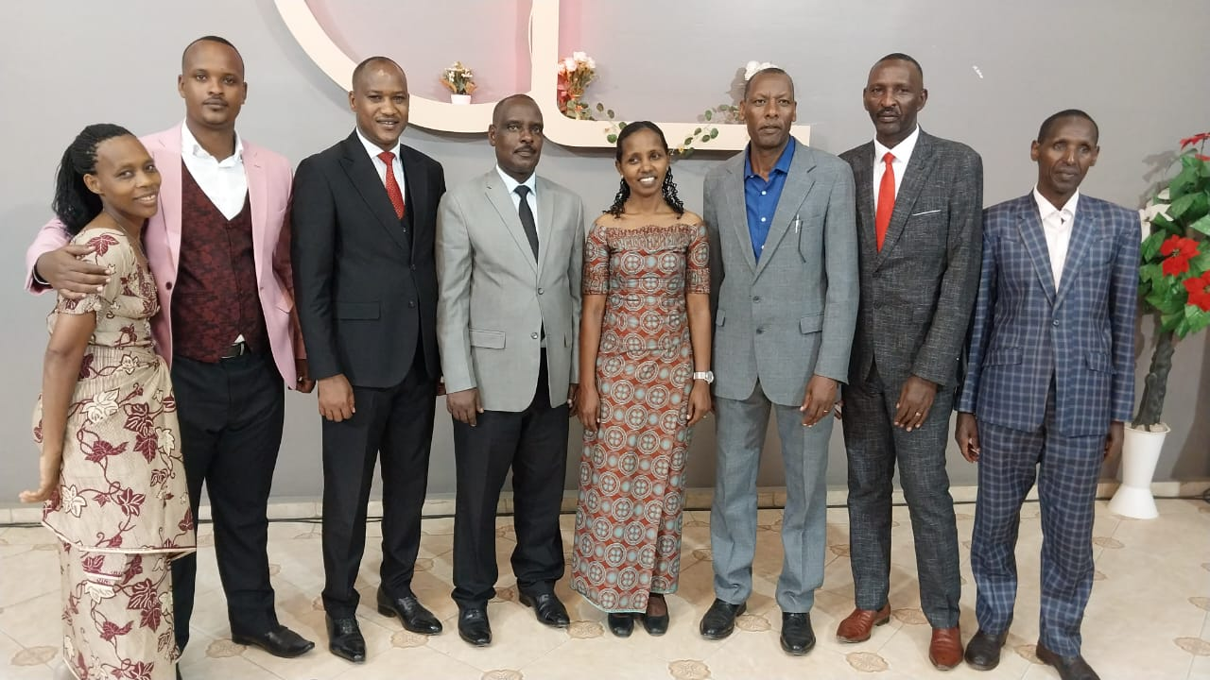
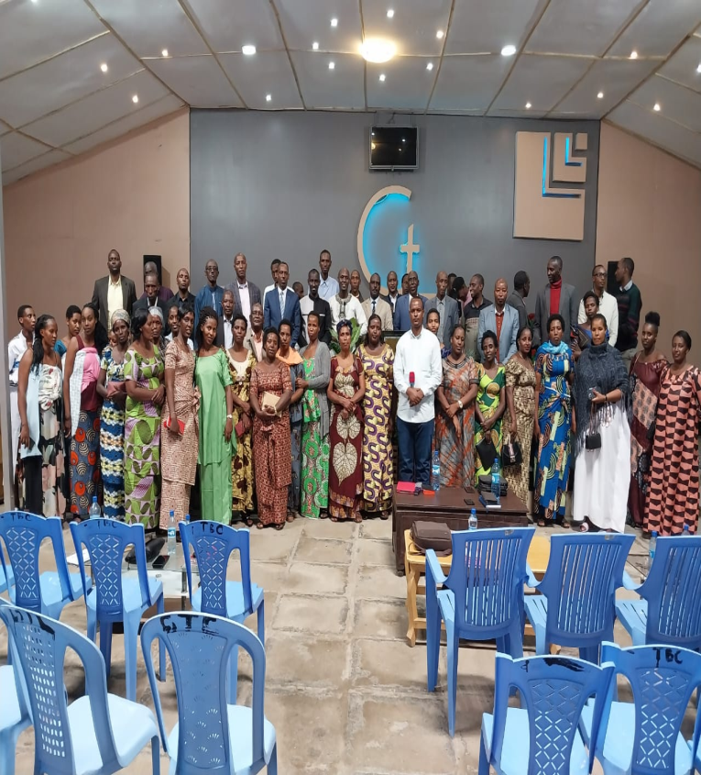
Church Leaders Training
Pastors and Church planters training
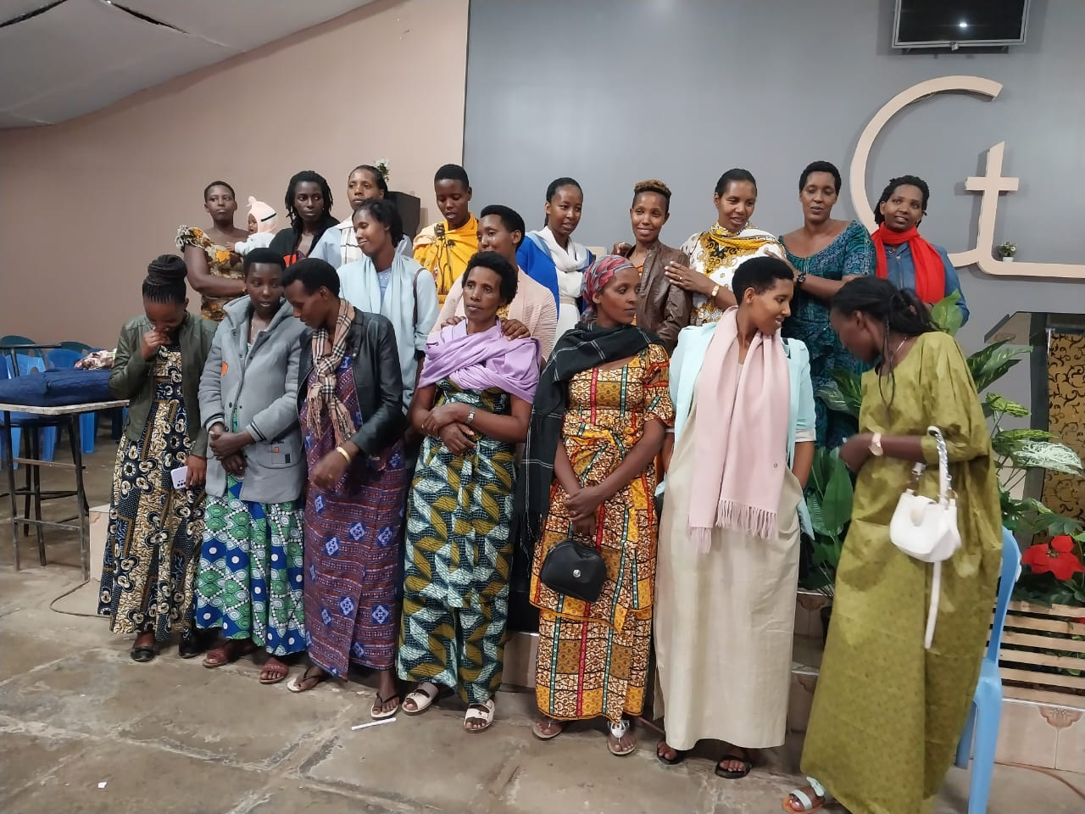
Women (Capacity Building and Small Business)
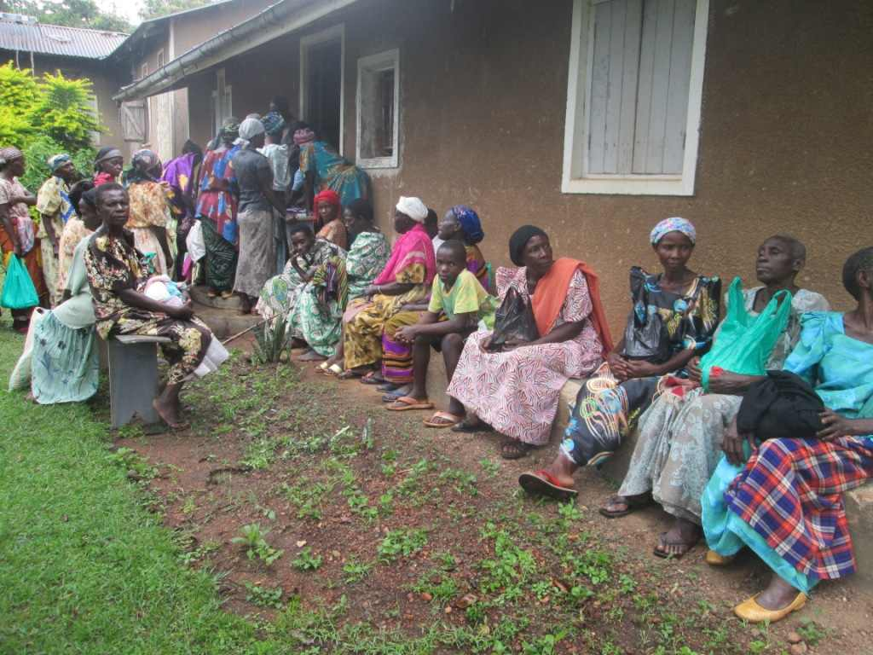
Women (Capacity Building and Small Business)

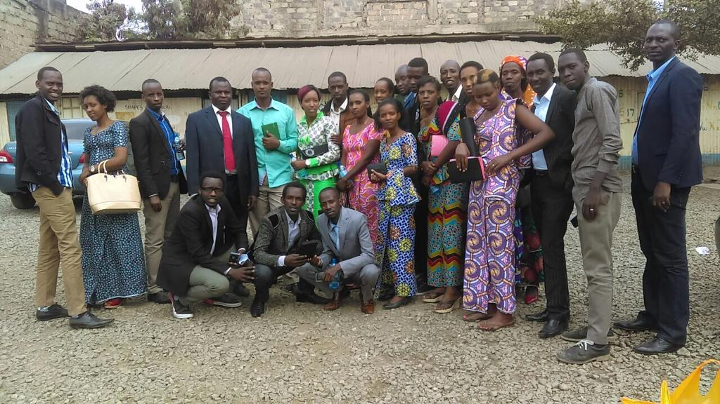
Youth Business Training

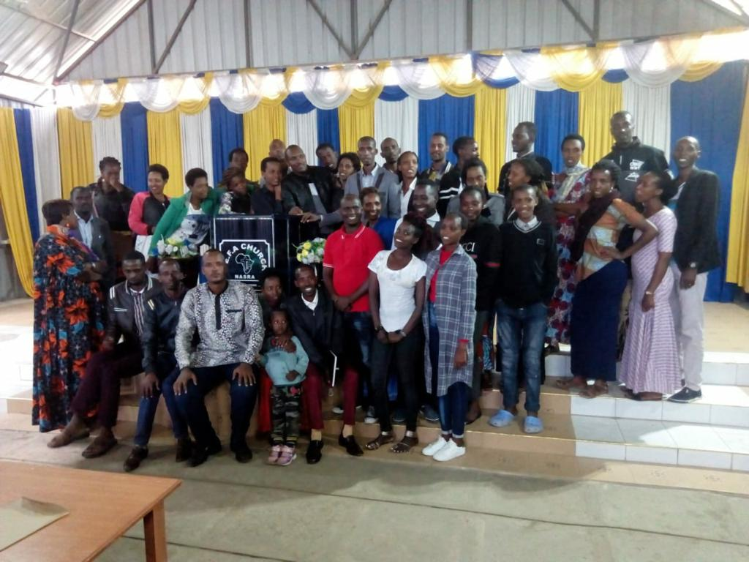
Youth Business Training

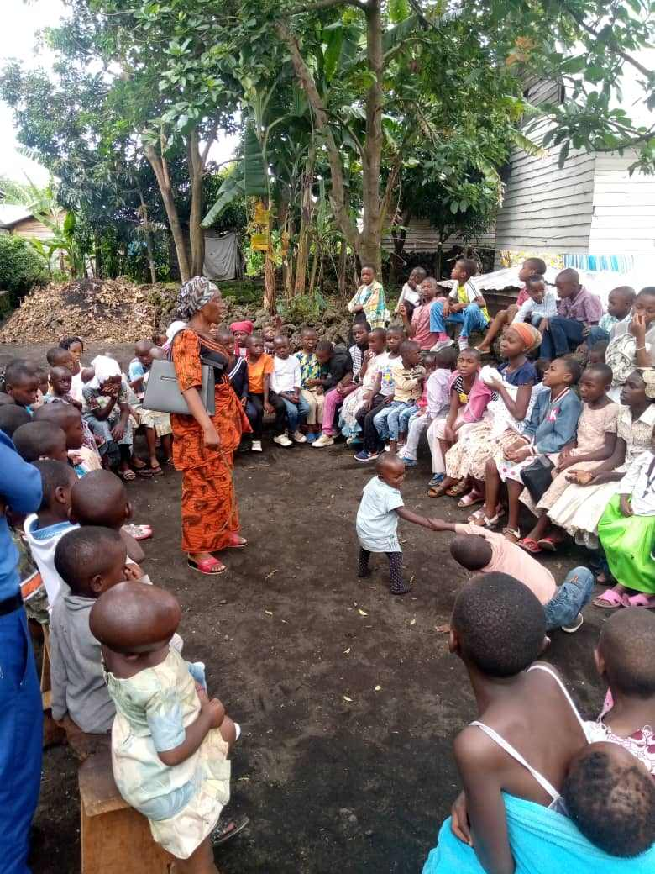
Orphans and Children with special needs (Orphan Support Meals, Health and Education)

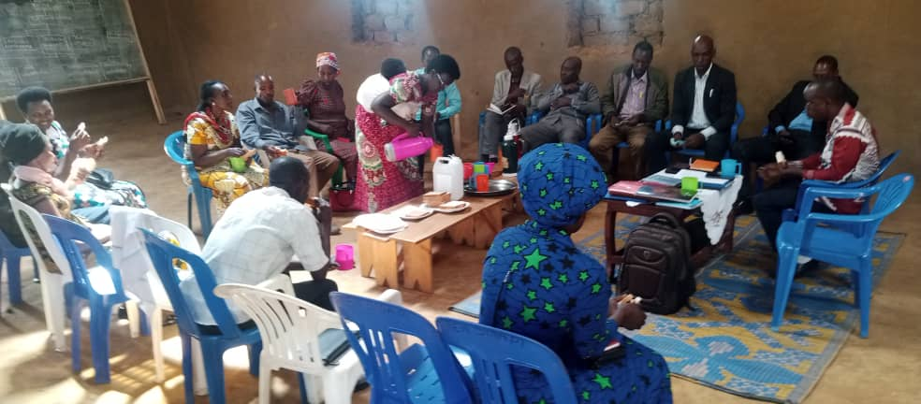 | 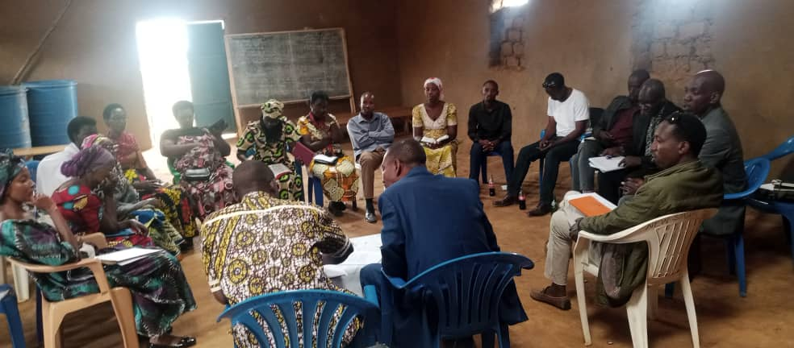
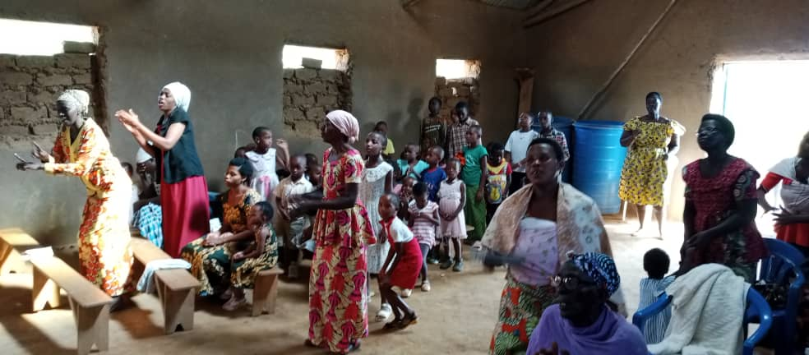 | 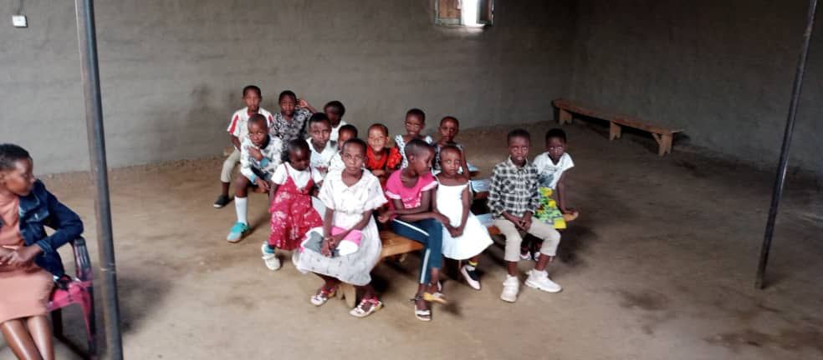

Other fellowship and networking event pictures

